Lecturer’s name: N/A | Date: Day 6
Course: Math | Unit: Equivalent Forms of Fractions, Decimals, and Percents
Unit Duration: 10 days | Lesson Duration: 1 day
TEKS: 6.4E, 6.4F, 6.5B, 6.5C | Lesson Part 2
Topic: Intro to Percent Proportion Formula

Lesson objectives:
- SWBAT calculate “the rest” of the values by adding them all up and subtracting from 100
- SWBAT use pictorial models to solve the part, whole or percent
- SWBAT use the percent proportion with real world scenarios

Essential Questions:
How can I use the percent proportion with real world problems?
What strategies can I use to find the different parts of a percent proportion?
What strategy can I use to find “the rest”?

LYS Methodology

Be (Character/Values/Principles) - Educational, Financial, Vocational, Spiritual, Cultural - How can I use the strategies in a percent proportion to figure out how to find other connected, responsible, and curious mentors in my life?

Know (What resources are available to the student/ How can they use them) - Educational and Health - How does practicing multiple percent proportion problems help me distinguish between moments of uncertainty in which I must ask for help or moments of assertiveness?

Do (Execute with Excellence) - Educational, Financial and Spiritual - How does percent proportions create resilience, dedication and time management?

Resources (Include Technology):
Instructional Input - Asynchronous
AS: Anticipatory Set (Introduction)
- Students warm up is changing between fraction, decimals and percentages
- FDP Conversions Quiz

M: Modeling (I do)
- Introduce Key Point 1: To find “the rest” I can add all the percentages I know and subtract from 100.
- Teacher Model 1:
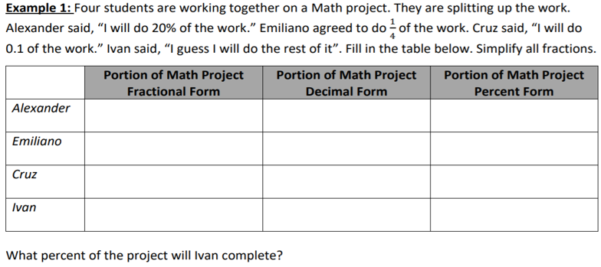

- Introduce Teacher Model 2 problem and complete along with students by asking questions such as: what is the first step? What happens next? How can I change from one form to the next?
- Check for Understanding: Create 1 question similar to Example 1 and 2

GP: Guided Practice (We do)
- Create 4 additional problems that involve changing between all 3 forms and then finding a missing value in either percent, decimal or fraction form
- 2 problems are working with a partner
- 2 problems working independently

Instructional Input - Synchronous
AS: Anticipatory Set (Introduction)
- Students warm up is changing between fraction, decimals and percentages
- FDP Conversions Quiz

M: Modeling (I do)
- Introduce Key Point 1: To find “the rest” I can add all the percentages I know and subtract from 100.
- Teacher Model 1:


- Introduce Teacher Model 2 problem and complete along with students by asking questions such as: what is the first step? What happens next? How can I change from one form to the next?
- Check for Understanding: Create 1 question similar to Example 1 and 2

GP: Guided Practice (We do)
- Create 4 additional problems that involve changing between all 3 forms and then finding a missing value in either percent, decimal or fraction form
- 2 problems are working with a partner
- 2 problems working independently

Independent Practice/ Homework
- Students complete online practice on FDP conversions - FDP Practice

Lesson Close

Spiritual
“Life doesn’t get easier or more forgiving, we get stronger and more resilient” - Steve Maraboli

How can I use the strategies in a percent proportion to figure out how to find other connected, responsible, and curious mentors in my life?
Working with the percent proportion requires for the learner to have a mindset of connectedness because of the various moving pieces a single problem contains. This is also applied to oneself as it opens learners to connect different phases of their lives from child, teenager, young-adult and so on. Being responsible and curious will be crucial in achieving the correct answers not only with percent proportions but in life. Being hungry for knowledge and responsible in following the steps to success will be an important foundation.

Because there are so many steps to follow with percent proportion problems, it can be easy to make mistakes and forget what to do next. What is important in these moments is knowing who you can reach out to for help. Similar to life problems, identifying key influencers in one's life to reach out in moments of doubt and fear will be crucial for a successful career.

